TRAINING AND PLACEMENT CELL
ACADEMIC YEAR 2024-2025
MOU with COMMONWEALTH STUDENTS ASSOCIATION on 10.01.2025
The Training and Placement Cell of AASC, is glad to share that we signed a MOU with COMMONWEALTH STUDENTS ASSOCIATION and Government of Penang, Malaysia on International Collaboration and students development activities on 10th Jan 2025. This MOU entails:
- COE - Growth understanding on sustainable development
- Students’ immersion program
- Internship/ placement/ higher studies counselling and guidance
- UNICEF AND UNESCO certified VAC
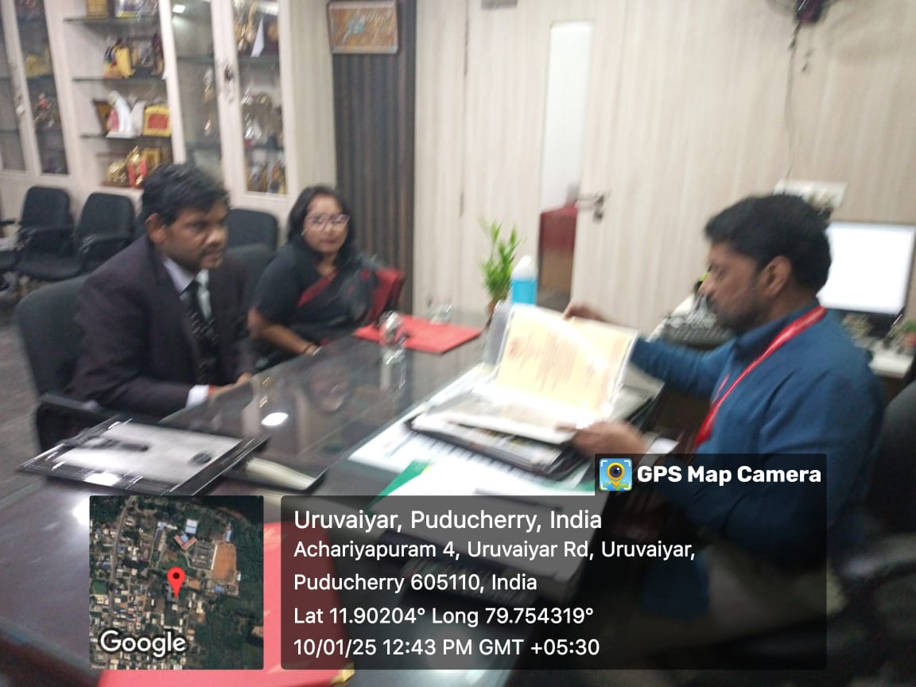
- Faculty immersion program

